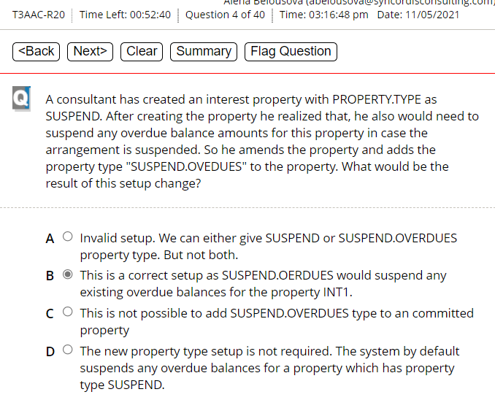

|  |
| --- |
| B seems to be correct |
| But doubt as it was counted as 0% at the end of exam:  TV: I think **C** is correct. If “Suspend” was originally stated, you can’t add “suspend overdues” |
|  |
| *Research done on the Question through Temenos Documentation and T24:* |
| PROPERTY.TYPE SUSPEND SUSPEND.OVERDUES  SUSPEND It indicates that the Property is allowed to suspend. Only INTEREST and CHARGE Properties can be suspended.  SUSPEND.OVERDUE It indicates that any overdues in the Property get suspended when Property is suspended.  To define SUSPEND.OVERDUE, the Property should already be set to SUSPEND. |
|  |
|  |
|  |
|  |
|  |
|  |
|  |
|  |
|  |
|  |
|  |
|  |
|  |
|  |
|  |

|  |
| --- |
| *A AA.PRD.DES.INTEREST should be correct? TV: Yes*  *researched in T24:* |

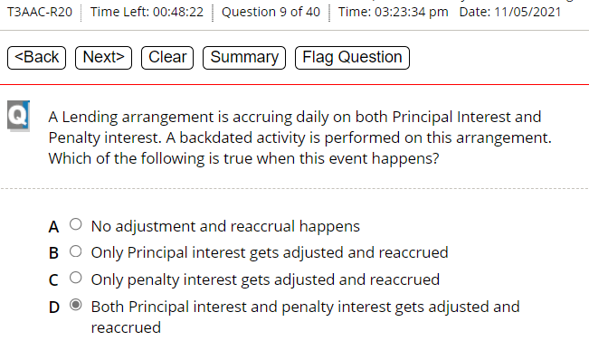

|  |
| --- |
| D seems to be the correct one => TV: Yes |
| recheck |

*Research done on the Question through Temenos Documentation:*

|  |
| --- |
| D seems to be correct? TV: I checked it. It is B |

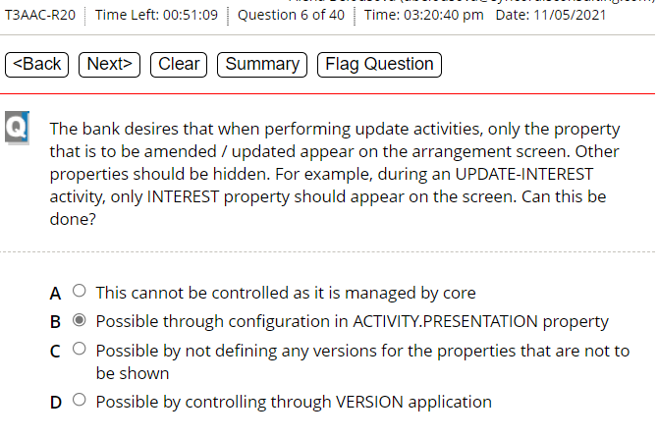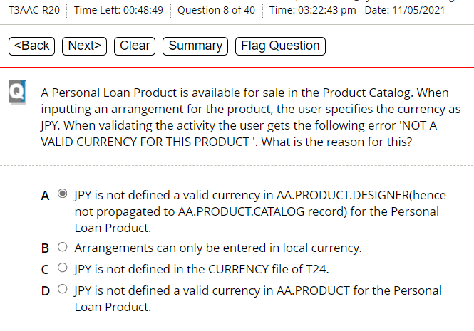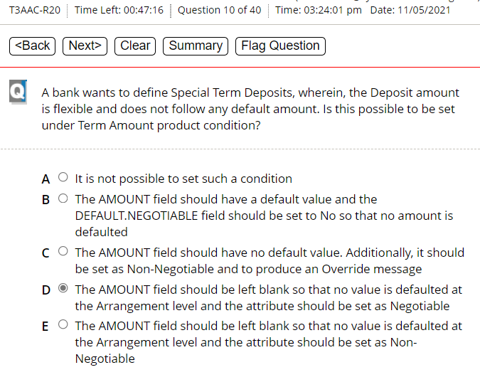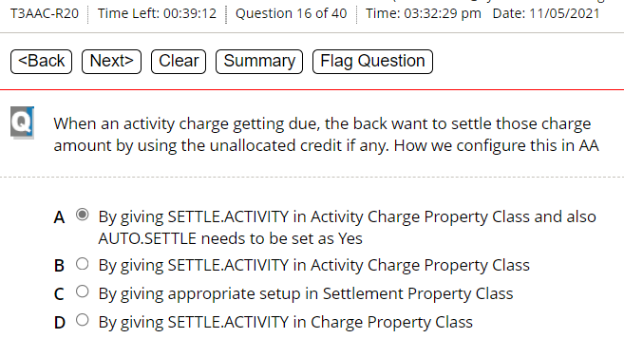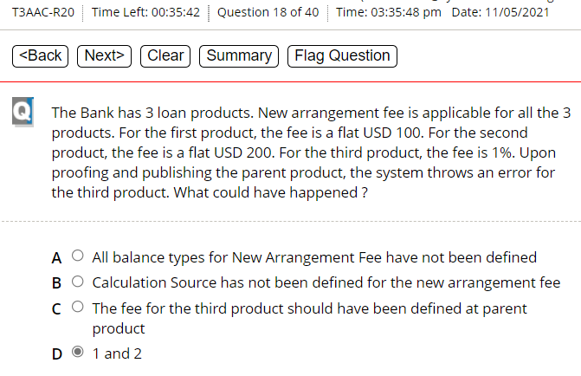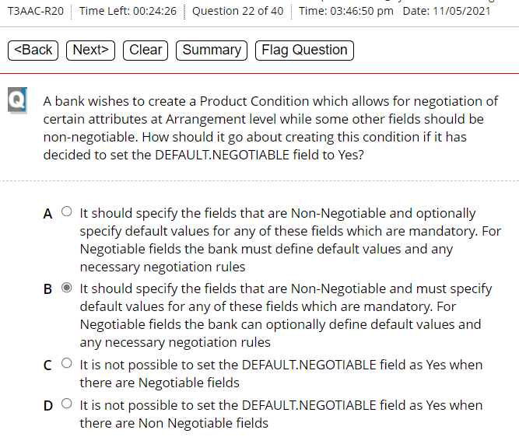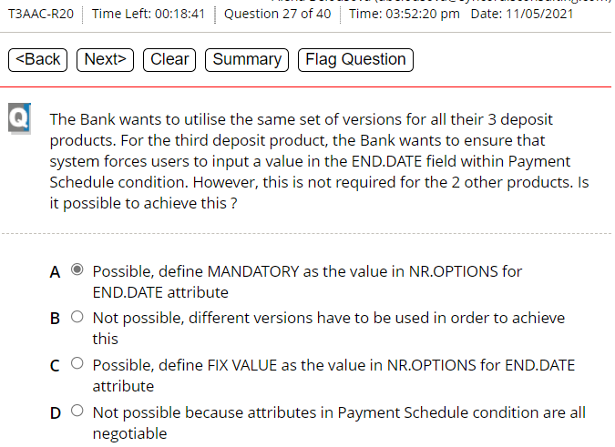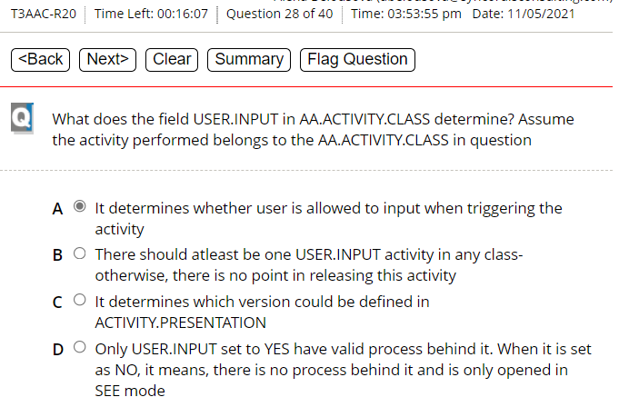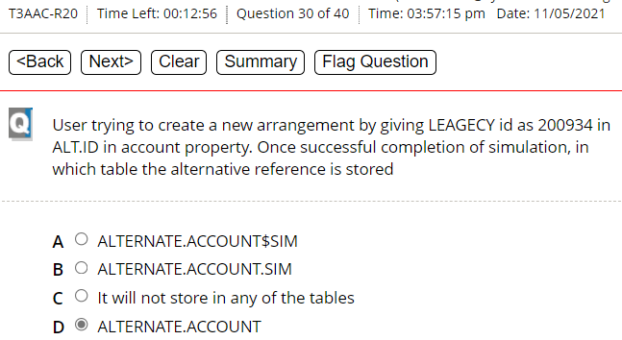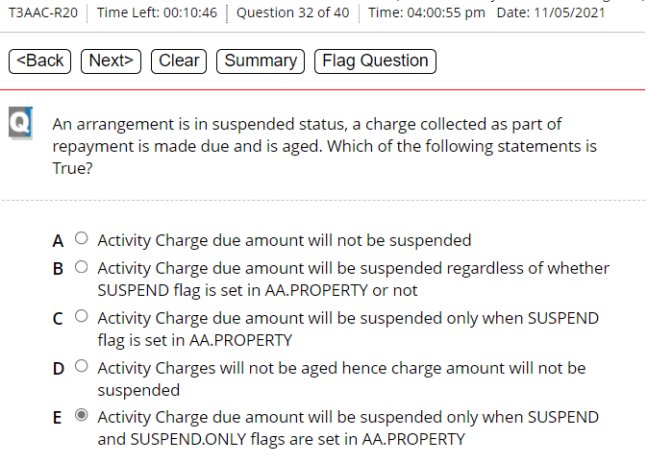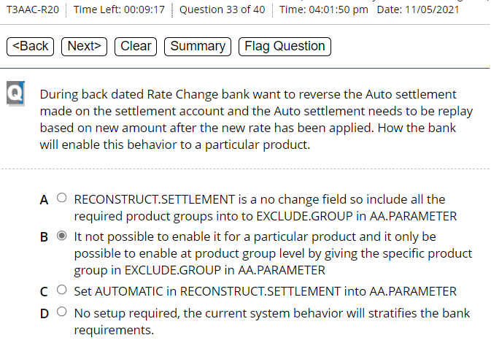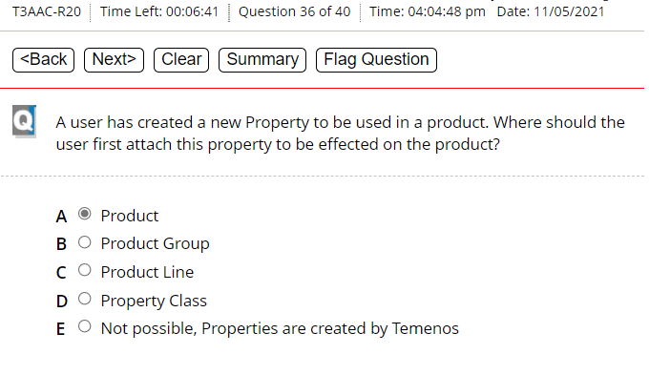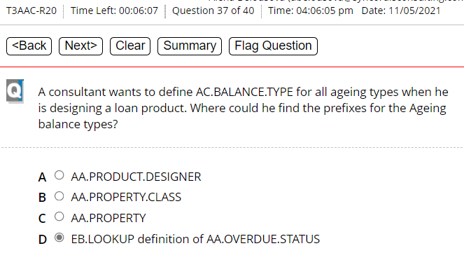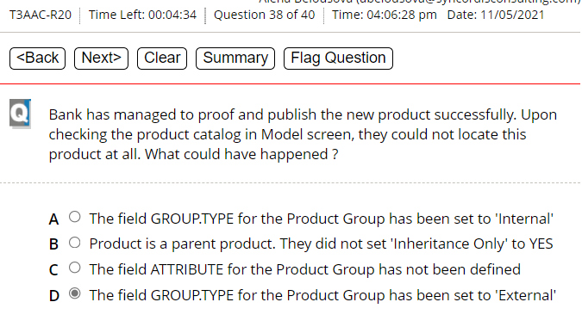

|  |
| --- |
| B seems to be correct? But doubt TV: A is correct |
| Research: |
| The CHARGE property class is used to define charges and can be added to PAYMENT SCHEDULE property class for defining scheduled charges. It is used in ACTIVITY CHARGE property class to define charges related to an activity. |
| AUTO.SETTLE – By configuring the *Auto* *Settle* field to YES in the ACCOUNT.ACCRUAL or ACCT.GROUP.CONDITION application. When this configuration is enabled and the user modifies the configuration of *Int* *No* *Booking* field from Suspense to None, the accrued interest or charge in the PL suspense account (for example, 51000SP) is moved to the respective PL account (for example, 51000) during COB processing.   |  | | --- | | **AUTO.SETTLE** | | Specifies whether the system must automatically raise the accounting transactions to move the IC P&L to xxxxxSP when an account is suspended and then move the xxxxxSP to P&L when the suspense is removed. | | If the indicator on ACCT.GROUP.CONDITION is not set, then the indicator on ACCOUNT.ACCRUAL is checked. | | Valid Option : 'YES', 'NO' or Null | |

B seems to be correct TV:I think so too, but based on Indian English experiences it might be also D in spite we just need one balance type for the 3rd fee

May be A is correct in this case TV: Yes, A is correct

|  |
| --- |
| **DESCRIPTION** |
| Describes the AA.PRODUCT.LINE and is used for enrichment. |
|  |
| This field can be expanded to allow the User to enter the Description of the AA.PRODUCT.LINE in various languages. Each expansion of the field will correspond to a new Language as defined in the LANGUAGE table (Ref: GENERAL TABLES), and will indicate to the User the Language in which the Description must be entered. |
|  |
|  |
| Up to 35 type A (alphanumeric) characters |

Product Lines “LENDING” -> is not possible to change

GB Description “Lending” -> is possible to change

*A seems to be correct or C. TV: I think A, but I am also not sure*

*Or to change Penalty int, proof and publish, then specify delay, then change Regular interest.*

Two attributes are available in **AA.PRODUCT.DESIGNER** table that allows the user to specify the number of days by which the tracking of condition is delayed to take effect for properties belonging to a Property Class.

B seems to be correct. TV: I would say A. They refer in the answer to the product condition, which is correct

C or/and E is correct? Rather C? TV: No, it is only E

|  |  |  |  |  |  |  |
| --- | --- | --- | --- | --- | --- | --- |
| |  | | --- | | **NR.MESSAGE** | | This field indicates whether to raise error or override message when rule is broken | | Allows only two values ERROR or OVERRIDE | | ERROR error message is raised | | OVERRIDE Override message is generated | |  | |
| |  | | --- | | **NR.OPTIONS** | | Defines named values to indicate if an option applies to the associated NR.ATTRIBUTE. More than one option can be associated with the NR.ATTRIBUTE, with certain restrictions. | |  | |  | | Valid Inputs are NEGOTIABLE, NON-NEGOTIABLE, OVERRIDE, FIX-VALUE, MANDATORY, COUNT as described below: - | |  | | NEGOTIABLE | | The value of NEGOTIABLE will indicate that the associated NR.ATTRIBUTE can be negotiated at the arrangement level. | |  | | NON-NEGOTIABLE | | The value of NON-NEGOTIABLE will indicate that the associated NR.ATTRIBUTE cannot be negotiated at the arrangement level. Both NEGOTIABLE and NON-NEGOTIABLE cannot be defined together | |  | | OVERRIDE | | Specifies if a default override message should be generated if the default attribute is amended at the arrangement level. If OVERRIDE is not specified, no override will be generated. | |  | | FIX-VALUE | | Specified if the field value is to be fixed at the arrangement level. If FIX-VALUE is not specified the field value will vary with the changes to the underlying product condition. | |  | | MANDATORY | | Specifies if the attribute is mandatory for this product condition. Can only be specified where the attribute is not defined as mandatory in the property class. | |  | | COUNT | | Specified to restrict the number of values that should satisfy the rule specified in NR.ATTRIBUTE.RULE. In absence of a rule, the count refers to the number of multi-value/sub-value. | | If the rule is not satisfied then error/override will be raised based on the NR.MESSAGE mentioned. | |

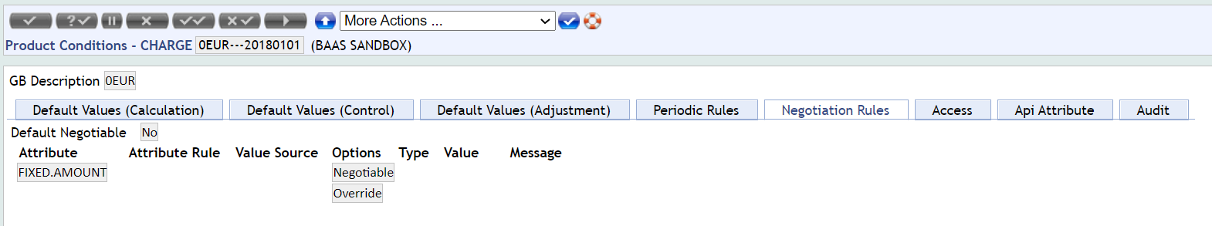

*ALT.ID will not be stored in any of the table given as answers options for this question.*

*ALT.ACCT.ID is stored in the ACCOUNT application*

*So, C or D may be correct TV: I have checked it. It is D*

***ALT.ACCT.ID or ALT.ID?***

|  |
| --- |
| **ALT.ACCT.ID** |
| Allows maintenance of alternate account identifiers for any alternate account system defined in the T24 system. Any alternate account system identifiers will appear in the previous field. |
| The account identifiers by which the user's T24 account is alternatively identified can be linked to the T24 account in this field. |
| The ALTERNATE.ACCOUNT application within T24 is maintained by this field. |
| Validation Rules: |
| Multi-valued field. |
| Optional input field. |
| Format is dependent on the definitions in the ALT.ACCT.PARAMETER application. |
| Entries in this field will be validated in accordance with the rules defined for each alternate account system in the ALT.ACCT.PARAMETER application. |

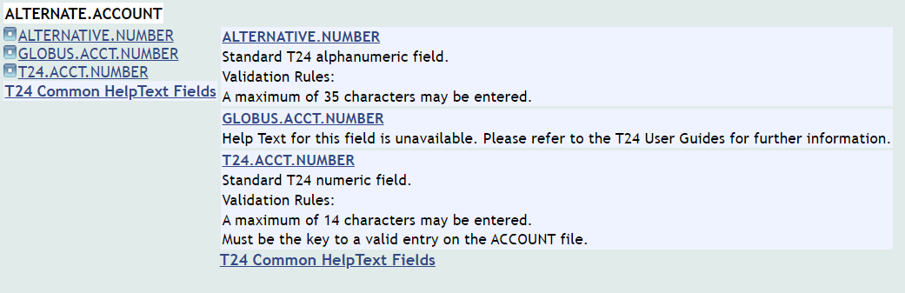

*May be B is correct if the question is about to enable it to a particular product TV: For me B is correct.*

*C is correct globaly, but not for particulat product*

*Or D:*

*Extract from Temenos Documentation:*

“The standard AA Reverse and Replay functionality is the default behaviour of the system to recalculate and repost interest/charges as a result of back-valued activities.”

|  |
| --- |
| **RECONSTRUCT.SETTLEMENT** |
| IIndicates whether the settlement processing for settlement account needs to be reversed and replayed with the new or changed amounts/rates. Once we opted the Automatic behavior then the behavior should not be changed to Manual or Null. After setting Automatic at global level(System) then system will not allow to set values at company level. |
| Note:Backdated settlement functionality is enabled only if settlement account is AR/AC Account alone |
| Available options are: |
| NULL/MANUAL - System will behave as existing old settlement process. |
| AUTOMATIC - System will behave in new way where settlement processing is reversed and replayed. |

D should be correct? TV: For me it is E

*A Product should be correct or*

*D Property Class or*

*B Product Group. TV: I think they mean B*

*D seems to be correct? TV: Yes, D*

|  |
| --- |
| **GROUP.TYPE** |
| Valid options are INTERNAL, EXTERNAL and FEATURE |
|  |
| INTERNAL - This means that the group being defined is the own Bank's product. Hence only products which are specified as INTERNAL are available for sale to customers. |
| EXTERNAL - There may be a necessity for Banks to do comparison between its own product(INTERNAL) and one by its competitor. Those groups may be defined as EXTERNAL. These products may then be used for comparitive analysis to show the superiority of Bank's own product. Products of this type are not available for sale to own customers. |
| FEATURE - This option will enables user to create the Products by using features. |

|  |
| --- |
| **ATTRIBUTE** |
| This field can be used for classifying the groups. The list of classification can be defined in the EB.LOOKUP file for AA.PRODUCT.GROUP.ATTRIBUTE. For example, a product group may cater to RETAIL banking, whilst another product may cater for PRIVATE banking. These classifications may be done using this field.Since the classification is 'soft', it is left to the discretion of the financial institution as to how they would want to group their products. |
|  |
| Validation rules: |
|  |
| Non Mandatory field. |
| Contents should be defined in EB.LOOKUP of AA.PRODUCT.GROUP.ATTRIBUTE. |
| For ONLINE.SERVICES product each product group will have a default coresponding Attribute value, for TC.RETAIL the Attribute RETAIL and for TC.CORPORATE the Attribute CORPORATE |

C is false as user can not define days, but months and years? So C is correct reply to this question? TV: I guess also C, although your statement is correct. This is the typical case of an unprecise question/answer

It is possible to combine and simulate two or more activities online, that is, without the use of a simulation service. This is achieved by setting the *Synchronous* field in the **AA.SIMULATION.RUNNER** record along with the simulation capture references of the respective activities.

|  |
| --- |
| **SIM.RETENTION.PERIOD** |
| Defines the period after which simulations identified by this row will be archived. Must be in the format of xxM (Months) or xxY (Years) only where xx is a value between 01 and 99. |

*C seems to be correct, but doubt.TV: C is correct*

*Extract from T24:*

|  |
| --- |
| CUSTOMER TRACKING |
| In this scenario, the customer wishes to define the Product Interest Rate at the Product level and default it to the underlying Arrangement. However, when required, they wish to negotiate certain values individually at the Arrangement Capture stage. |

*For this one I really do not have an idea. TV: I think A, as multiple disbursements are alwys possible. But as I know the indian guys they want to hear B*

1. *ADVSUSPENSE and c.) ADSSUSPENSE should be correct so far investigated TV: I think it is answer C, but I am not sure*

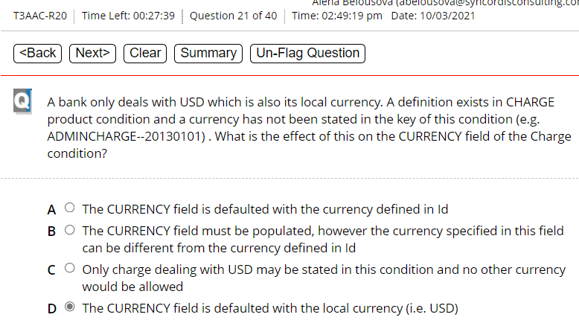

*May be C is correct? TV:It is B*

*Doubt between C or D options. TV: It is C*

*If External products are available to take arrangements, then C should be correct. It it not crystal clear, what is meant with “it has been set to look at a PARENT.PRODUCT in product designer”*

*Screenshot from Temenos Documentation:*

*A AA.EXCEPTION.LOG seems to be correct? TV: From the name of the file I would opt for B, but I am not 100% sure*

TV: C is correct